Gamma ray spectroscopy with Ge(Li) and Abundance of Uranium Isotopes

ANALYSIS NOTE
The primary objective was to collect data of the energy spectrum for Cobalt-60, Cesium-137, Europium-152 and Barium-133. The tasks of the experiment are:
1) Finding the calibration formula and obtaining the relative detector efficiency.
2) Finding the Uranium abundance by calculating N(235)/N(238).
INSTRUMENTAL SPECIFICATIONS:
Lab gain settings:
- Fine gain: 1.195
- Course gain: 20
- Shaping: 3 microseconds
- Total = 23.9
DATA COLLECTED:
Table 1: Data collected for Cs, Co and Ba
Element | Bin | Peak | Mean | Rms | Count | EOM | Precision | Gamma
Cesium-137 | 3558.0 | 263.0 | 3556.63 | 3.70 | 2302.0 | 0.08 | 2.08 | 661.657
Cobalt -60 | 6202.0 | 145.0 | 6202.35 | 5.30 | 1508.0 | 0.14 | 2.58 | 1173.228
Cobalt - 60 | 7026.0 | 120.0 | 7025.48 | 5.25 | 1246.0 | 0..15 | 2.83 | 1332.492
Barium - 133 | 1563.0 | 115.0 | 1563.92 | 5.00 | 968.0 | 0.16 | 3.21 | 274.6
Barium - 133 | 1701.0 | 257.0 | 1700.73 | 3.05 | 1792.0 | 0.07 | 2.36 | 302.851
Barium - 133 | 1976.0 | 669.0 | 1976.66 | 2.90 | 4607.0 | 0.04 | 1.47 | 356.013

EQUATIONS USED:
$$Detector Efficiency=\frac{N_i}{\left(\frac{N_{ref}}{I_{ref}}\right)*(I_i)}$$
Here N_i: The number of counts in the rest of the peaks, I_i: the corresponding relative intensities of the peaks.

Isotopic Ratio:
$$number of gammas emitted=\frac{number of gammas in the peak}{efficiency}$$

$$number of decays of uranium =\frac{number of gammas emitted}{Relative Intensity}$$

$$number of atoms of uranium=\frac{number of decays of uranium}{λ}$$
$$λ=\frac{\log_{2}2}{t_{1/2}}$$
$$Isotopic ratio=\frac{number of atoms of U235}{number of atoms of U238}$$

$$Percentage value=\frac{number of atoms of U235}{number of atoms of U235+number of atoms of U238}$$

Energy Calibration:
DAY: 01
Europium-152
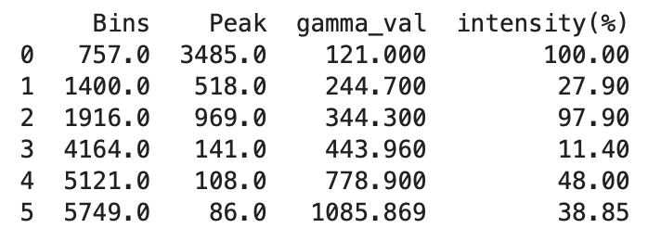
Figure 1: Europium peaks and corresponding gamma energy values
Using the bin count and the corresponding gamma values for Cesium, Cobalt and Barium, the Gamma energy vs Bin count graph was obtained. This graph was used to obtain the calibration fit function.
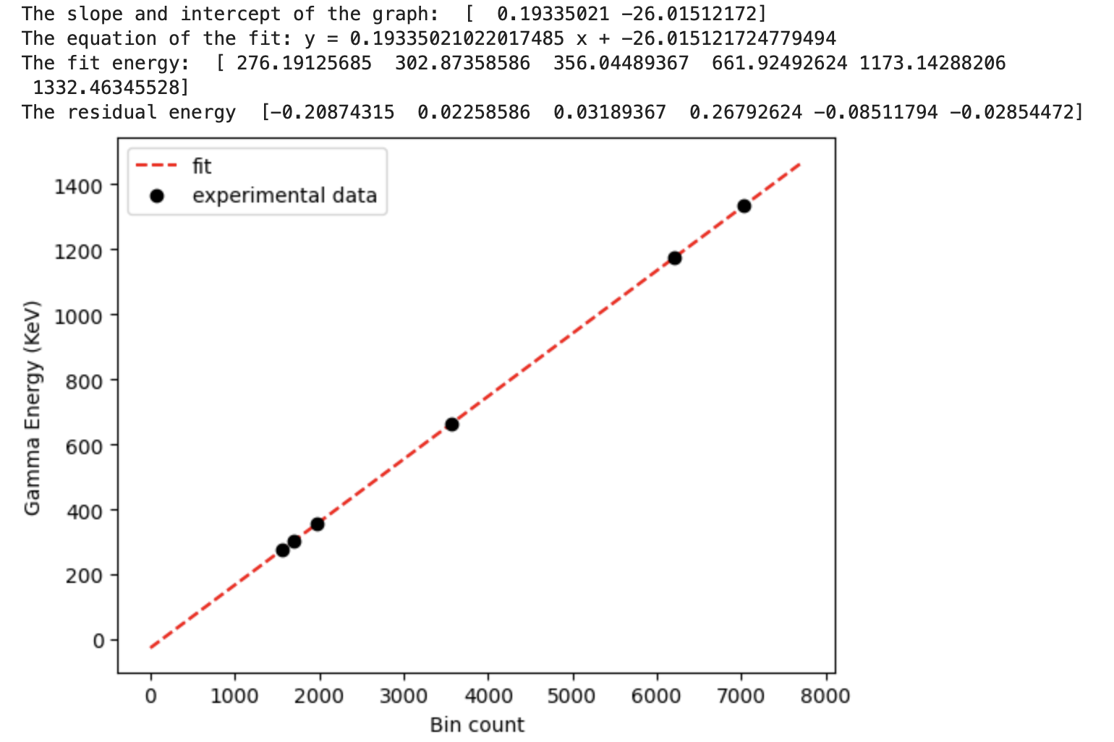
Figure 2: Energy calibration fit function
The calibration function is y = 0.193x – 26.015

The corresponding gamma ray energies for Eu-152 peaks:
Table 2: Gamma ray energies
Literature | Experimental | Residual
121.000 | 120.350 | -0.6490
244.700 | 244.675 | -0.0248
344.300 | 344.443 | 0.1438
778.900 | 779.095 | 0.1951
964.079 | 964.131 | 0.0523
1085.869 | 1085.555 | -0.3137

DAY: 02
Europium-152
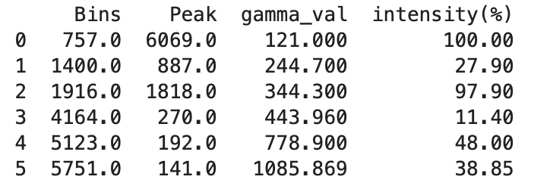
Figure 3: Europium peaks and corresponding gamma energy values
The calibration function is y = 0.193x – 26.015
The corresponding gamma ray energies for Eu-152 peaks:
Table 3: Gamma ray energies
Literature | Experimental | Residual
121.000 | 120.350 | -0.6490
244.700 | 244.675 | -0.0248
344.300 | 344.443 | 0.1438
778.900 | 779.095 | 0.1951
964.079 | 964.518 | 0.4390
1085.869 | 1085.941 | 0.0729

Day 03:
Europium-152
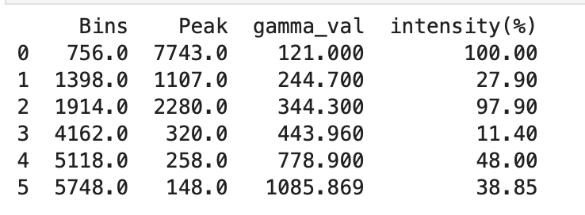
Figure 4: : Europium peaks and corresponding gamma energy values
The calibration function is y = 0.193x – 26.015
The corresponding gamma ray energies for Eu-152 peaks:
Table 4: Gamma ray energies
Literature | Experimental | Residual
121.000 | 120.157 | -0.8423
244.700 | 244.288 | -0.4115
344.300 | 344.057 | -0.2428
778.900 | 778.708 | -0.1915
964.079 | 963.551 | -0.5277
1085.869 | 1085.361 | -0.5071

Analysis for Energy Calibration:
The channel number in which the Europium peaks are observed is within the same range of values. As it can be observed that the residual energy is extremely small for Cobalt, Cesium and Barium, therefore the calibration function can be considered accurate. In order to be certain of the accuracy I used the Europium bin counts to obtain the potential gamma energy values. Here it can be seen that the residual energies for Europium-152 are extremely small and therefore it establishes the fact that the calibration function is accurate. Data taken in the three days are nearly close to one another establishing the fact that the experiment is pretty consistent. The residual energies for Day 1 and Day 2 show minor variations for the last two gamma values whereas Day 3 has a variation within the range 0.3-0.5.
Data taken on the first day are for a duration of 15-20 mins. Therefore, the precision is within the range of 2-3%. The second day data were taken for a longer time (30mins each) for Europium and Uranium and the precision is in range of 0.5-2.5%. The third day data values were taken for around 35-40 mins and the precision is in the range 0.5-2.0%. It’s observed that as the number of counts increases the precision gets lower. Hence the data taken are more accurate.

Relative Detector Efficiency:
The reference peak:
N_ref | 19578.5
Gamma_ref | 121.00
I_ref | 100

The corresponding peaks:
N_i | I_i
2850.0 | 27.9
6790.0 | 97.9
1229.0 | 48.0
1196.9 | 53.5

Using the reference peaks and the relative intensities of the rest of the peaks the detector efficiency was calculated.
Day 1:
Table 5: Uranium data values - Day1
Peak | Channel Number | Gamma energy | Intensity
Uranium-235
1446.0 | 873.0 | 143.76 | 10.96
915.0 | 976.0 | 163.33 | 5.08
7505.0 | 1093.0 | 185.715 | 57.2
900.0 | 1195.0 | 194.94 | 0.63
Uranium-238
432.0 | 5313.0 | 1001.7 | 0.838
261.0 | 4099.0 | 766.36 | 40

Day 2:
Table 6: Uranium data values - Day2
Peak | Channel Number | Gamma energy | Intensity
Uranium-235
3567.0 | 873.0 | 143.76 | 10.96
2307.0 | 976.0 | 163.33 | 5.08
19068.0 | 1093.0 | 185.715 | 57.2
2090.0 | 1195.0 | 194.94 | 0.63
Uranium-238
1140.0 | 5313.0 | 1001.7 | 0.838
672.0 | 4100.0 | 766.36 | 40

Day 3:
Table 7: Uranium data values - Day3
Peak | Channel Number | Gamma energy | Intensity
Uranium-235
2404.0 | 872.0 | 143.76 | 10.96
1494.0 | 975.0 | 163.33 | 5.08
12223.0 | 1091.0 | 185.715 | 57.2
1434.0 | 1194.0 | 194.94 | 0.63
Uranium-238
711.0 | 5308.0 | 1001.7 | 0.838
434.0 | 4095.0 | 766.36 | 40

The Uranium sample contained both isotopes U-235 and U-238. In the low energy spectrum the energy peaks for U-235 was observed and in the high energy spectrum the energy peaks for U-238 was observed. For U-238 I chose the peaks with the highest number of counts for lower precision.
Efficiency calculated:
Day 1:
Table 8: Efficiency calculated for Eu and Ur-Day1
 | Europium | Uranium
Efficiency | 0.52184 +/- 0.00094 | 0.73593 – U235
 | 0.35427 +/- 0.00545 | 0.69094 – U235
 | 0.13077 +/- 0.00048 | 0.65153 – U235
 | 0.11418 +/- 0.00041 | 0.11135 – U238
 | 0.10445 +/- 0.00104 | 0.12643– U238
Day 2:
Table 9: Efficiency calculated for Eu and Ur - Day2
 | Europium | Uranium
Efficiency | 0.52094 +/- 0.00086 | 0.72825 – U235
 | 0.35798 +/- 0.00550 | 0.68474 – U235
 | 0.13041 +/- 0.00034 | 0.63693 – U235
 | 0.10768 +/- 0.00023 | 0.10609 – U238
 | 0.10212 +/- 0.00089 | 0.11426 – U238

Day 3:
Table 10:Efficiency calculated for Eu and Ur - Day3
 | Europium | Uranium
Efficiency | 0.51462 +/- 0.00084 | 0.70790 – U235
 | 0.36131 +/- 0.00555 | 0.66745 – U235
 | 0.12720 +/- 0.00031 | 0.62293 – U235
 | 0.10050 +/- 0.00019 | 0.11179 – U238
 | 0.13840 +/- 0.00117 | 0.04734 – U238
Isotopic Abundance:
Day 1:
The function is:
$$y_le=2.186*{10}^{\left(-6\right)}x^{2}-2.970*{10}^{-3}x+1.118$$
$$y_he=-5.603*{10}^{\left(-8\right)}x^{2}+3.498*{10}^{-5}x+1.325*{10}^{-1}$$
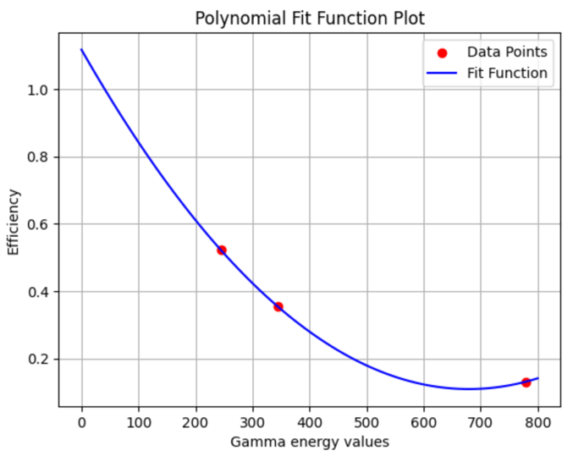
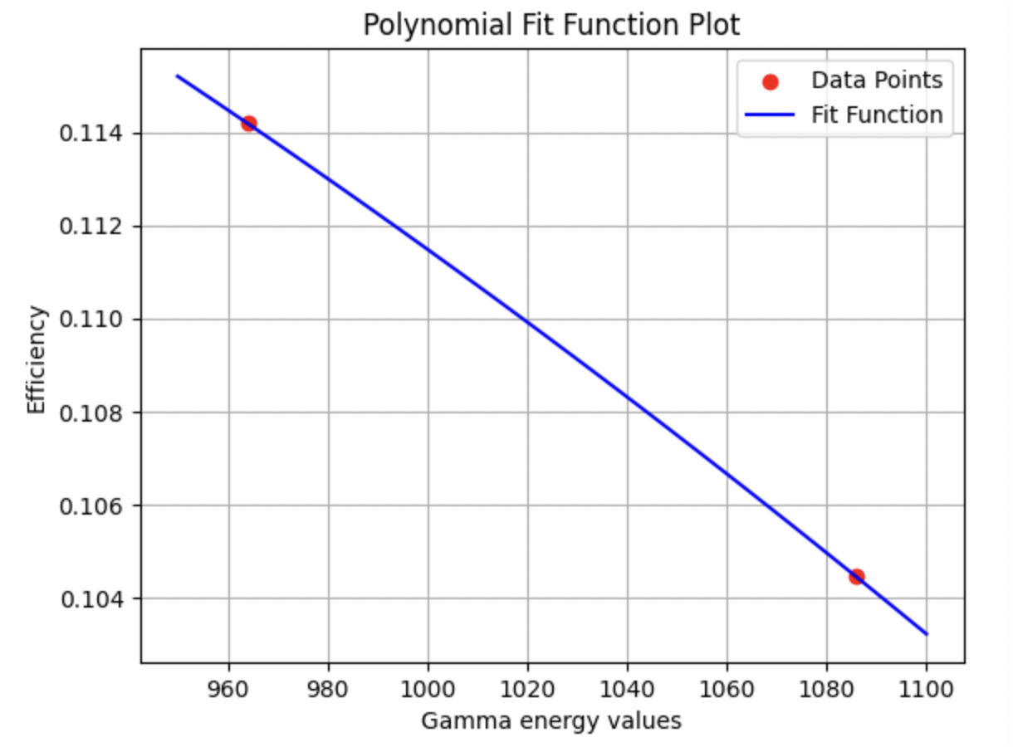
Figure 5: Energy calibration – low energies and high energies
Table 11: Isotopic ratio and percentage value of U-235 with respect to U-238
 | Isotopic ratio | Percentage value U-235
 | 0.007146 | 0.0070957

Day 2:
The function is:
$$y_le=2.083*{10}^{\left(-6\right)}x^{2}-2.863*{10}^{\left(-3\right)}x+1.097$$
$$y_he=-3.869*{10}^{\left(-8\right)}x^{2}-3.367*{10}^{\left(-5\right)}x+1.112*{10}^{-1}$$

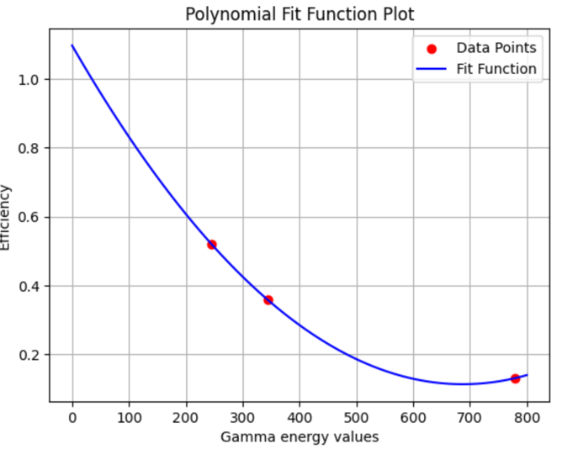
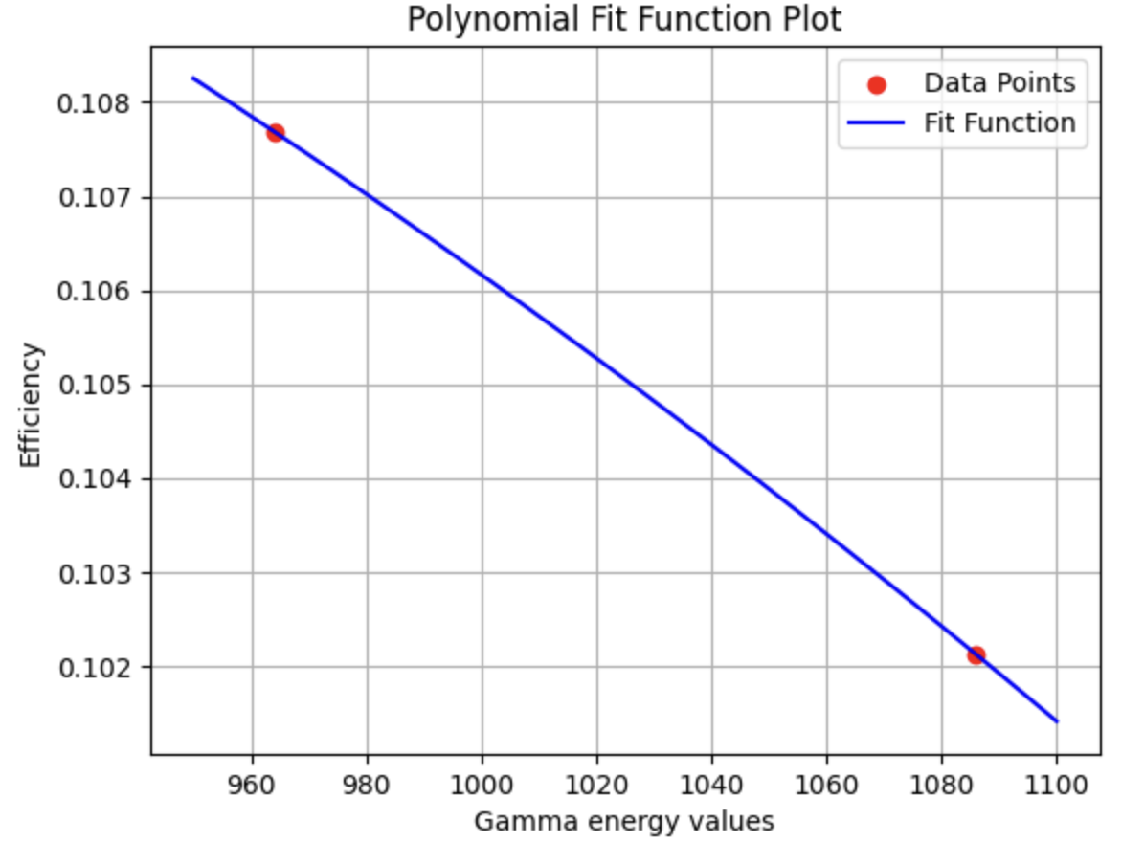
Figure 6: Efficiency calibration function – low energies and high energies
Table 12:Isotopic ratio and percentage value of U-235 with respect to U-238
 | Isotopic ratio | Percentage value U-235
 | 0.00655 | 0.00661

Day 3:
The function is
$$y_le=1.873*{10}^{\left(-6\right)}x^{2}-2.643*{10}^{-3}x+1.049$$
$$y_{he}=1.325*{10}^{\left(-7\right)}x^{2}-3.962*{10}^{-5}x-6.082*{10}^{-2}$$

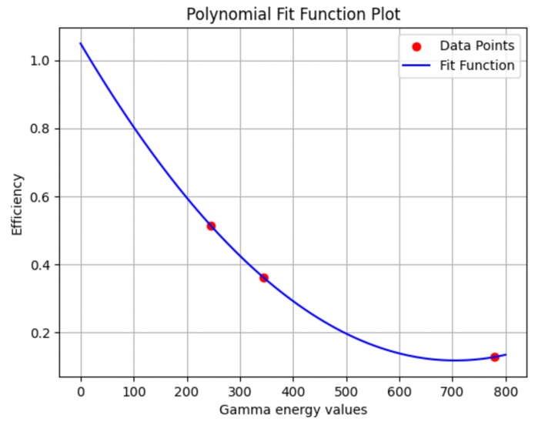
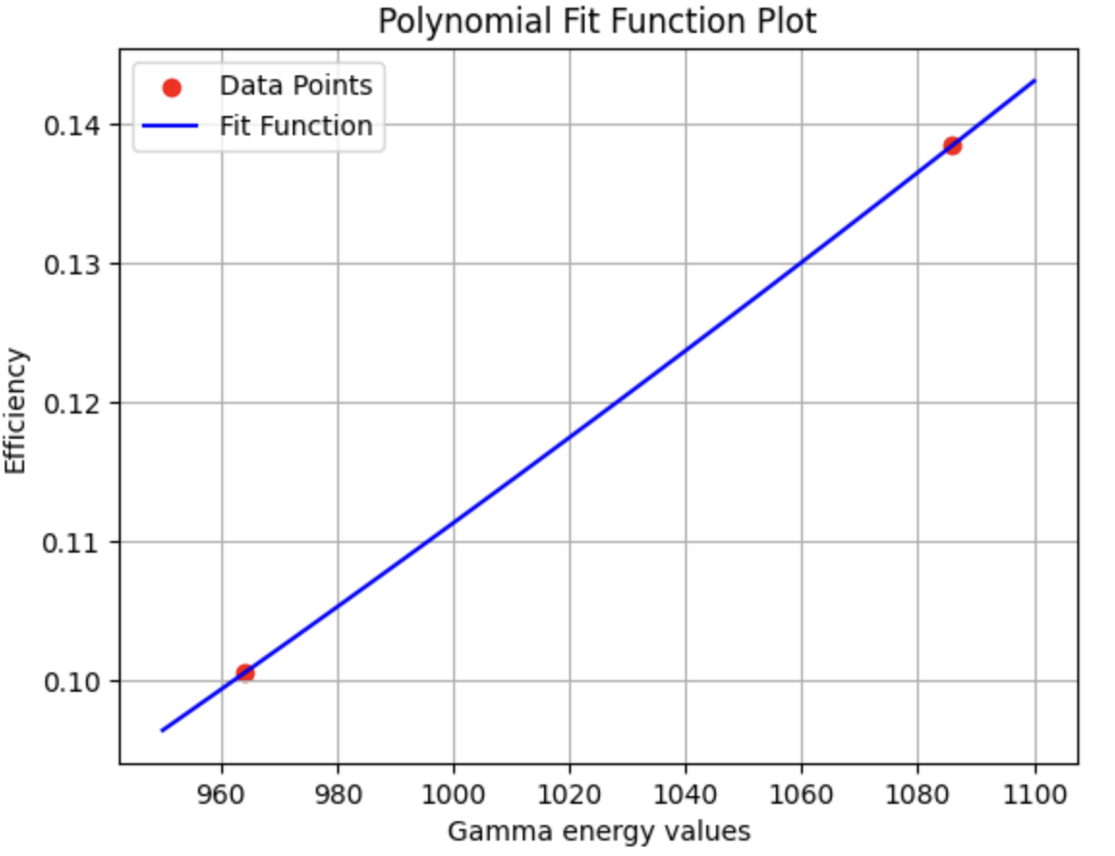
Figure 7: Energy calibration function – low energy and high energy

Table 13: Isotopic ratio and percentage value of U-235 with respect to U-238
 | Isotopic ratio | Percentage value U-235
 | 0.007252 | 0.007200

The Actinium series and the Uranium series are the decay chain of Uranium 235 and Uranium 238 respectively. In the energy spectrum of Uranium it can be seen that the energy peaks correspond to the energy of the emitted particles. Significant peaks can be identified that coincides with Thorium in the Actinium series.
In natural uranium, U-235 is ~0.72% and U-238 is ~99.28%. Therefore, the ratio is around 0.0072. Values were calculated for two U-235 peaks respective to two U-238 peaks. It was observed that some peaks have a higher background noise and utilizing those peaks gave erroneous values. Hence, I had to consider the first two peaks of uranium-235 and the two peaks of uranium-238. The percentage value for Uranium 235 during all three days are 0.0070, 0.0066, and 0.0072. Hence it can be considered a typical natural isotopic abundance. If the percentage of uranium 235 is less than 0.72% then it can be said that the uranium is depleted. Since the percentage values are within the natural uranium range it can be said that the sample used in this experiment is natural uranium.

